Newspaper Block Segmentation using Run-Length Smoothing Algorithm

Abstract
Region findings and analysis plays an important role in document understanding. Due to complex layouts, document understanding is a very challenging task for researchers. Layouts in newspapers are derived for the articles where article consists of multiple blocks. These various blocks must be segmented and identified within the whole newspaper which helps further in article segmentation. This paper proposes a simple method to identify and segment blocks found within the newspaper irrespective of its layout using simple image processing operations such as morphological dilation and run-length smoothing algorithm. These methods have been experimented on collected digital newspaper images of recent years with different layouts. As a result, our algorithm segments various blocks including texts, images and graphics in the newspaper and extract them as separate elements. Effectively these blocks will be used as features and evaluation measure for article segmentation algorithm.

Keywords – Region findings, Document understanding, Layouts, Dilation

I. INTRODUCTION
Document Digitisation is the process of taking a physical document or document representation and transferring it into a faithful digital representation. The ideal goal is to preserve all the information contained within the physical document as physical documents deteriorate overtime. It also achieves the goal of improved access, as digital documents can be quickly retrieved from archives and returned to a user, without them having to be in the same physical location as the document. Digitisation is necessary to allow sophisticated computer processing of documents.
Document layout analysis plays a vital role in processing the digitized documents in an efficient way and acts as a pre-processing step. The task of document layout analysis involves identifying and categorizing regions of interest on a given document image. Due to the complex layouts found in document image document understanding and analysis becomes difficult and in past many works has been initiated on this, but due to complexity of document it still remains as a challenging task and need to be addressed. This paper proposes a simple method to identify and segment blocks found within the newspaper irrespective of its layout using simple image processing operations such as morphological dilation and run-length smoothing algorithm. These methods have been experimented on collected digital newspaper images of recent years with different layouts. As a result, our algorithm segments various blocks including texts, images and graphics in the newspaper and extract them as separate elements. Effectively these blocks will be used as features and evaluation measure for article segmentation algorithm.
The remaining part of the paper is structured as follows: in the next section related work on block segmentation is presented. Section III explains proposed methodology and gives details about each module of proposed approach. Section IV describes experimental results & discussions respectively. Section V concludes the paper and provides the future directions.

II. RELATED WORK

There has been a wide range of literature available on topic document understanding and analysis. Tuan Anh Tran et al. (2018) [1] proposed an efficient hybrid method for page segmentation. The method includes two parts classification and segmentation. Connected component analysis and white space analysis are used for classifying text and non-text regions. Text regions during segmentation are retrieved by white space analysis and mathematical morphology. Non-text regions like graphs, tables, charts and many more are retrieved by ML process. Empirical computations on UWIII dataset found to be promising and faster. Processing time reduced by 1/3 when compared to multilevel algorithms. Hybrid methods based on morphological operations, contour classification, connected components have been proposed by (Nikos Vasilopoulos, Sebastian W. Alarcon Arenas et al.) their findings include titles, text and non-text regions respectively.
Nasid Habib Barna et al. (2018) [2] presents a language independent segmentation system based on morphological operations which takes the input as heterogeneous document and produces output as homogenous components. The system segments homogenous components as title, image, and tables. Authors in order to improve the segmentation performance of the system have proposed two more methods RIFR and TETC and have achieved an overall accuracy of 93% but still failed in segmenting images and tables properly hence need to be addressed.
A key contribution by Anukriti Bansal et al. (2014) [5] in automatically learning the rules to identify the logical units of a given document image outperforms the available systems that rely on learning the rules to detect logical units. The proposed model fixed point model captures the conceptual information to predict the label of each block present in the news articles and therefore the model attained promising results.
Annus Zulﬁqar et al. (2019) [6] proposed a deep learning technique for logical layout analysis. The proposed method uses two layered RNN where text is passed as an input to the model where it tries to find and label zones. Empirical computations shows that the model achieves accuracy of 95.38% with random split and 96.21% for unseen layout from this the model works well for even the unseen layouts when compared to random split. Further the model can be trained to predict the corners of text blocks and with larger dataset size.
Dario Augusto Borges Oliveira et al. (2017) [7] proposed reduction in dimensionality (from 2D to 1D) based classification approach. The proposed architecture takes as an input two 1D arrays of horizontal and vertical projections of image tile and classifies them into text, images, tables then final class labelling assignment done. Empirical results shows that the proposed architecture outperforms state-of-art techniques by low data usage 50 times less and increasing the processing time by 7.8 times faster. Further the architecture can be improved by dealing with historical data and by increasing labels.
As a replacement to conventional CNN Sai Chandra Kosaraju et al. (2019) [8] introduces a new model “texture-based CNN” for layout findings and analysis. The model uses dilated CN layers which takes a tile image and generates a class label thereby outperforming the available conventional CNN techniques in classifying documents. Looking back to the complexities involved in understanding the structure of a newspaper document Hui-Yin Wu et al.(2019) [13] proposed an approach towards understanding the structure and design of newspaper image. The approach takes as input the front page of newspaper and produces number of elements and design as output and is carried out in two stages a) Segmentation and b) Classification. Computer vision techniques are used for segmentation via curvilinear structure detection. CNN techniques are used for classification via fastai library. Finally both a quantitative analysis and a qualitative visualization is presented to users as result .
S. Pletschacher et al. (2010) [26] describes XML based PAGE framework in evaluating datasets in any infrastructure a research infrastructure, a production environment infrastructure. Due to its promising and efficient evaluation results the framework is now extensively used in many competitions series ICDAR, PRImA. Based on requirements the existing format can be extended to new gts subformats.
Focusing towards developing document layout evaluation system and page segmentation methods Thomas Strecker et al. (2009) [12] developed MyNews ground truth dataset generation system for newspaper layout analysis. The system takes as input news corpus and generates digital newspaper and XML file as output. The proposed system involves two stages a) layout generation b) Matching stage. The matching stage involves the fallowing steps a) Document is printed b) Scanning document c) Document image alignment that relies on RAST algorithm to find optimal parameters and finally d) Computing the coordinates of ground truth components in scanned image. Thus, generating a dataset with some layouts and as a future step the system can be extended to cover more general datasets.
From the above literature survey, it is found that the research work on document layout analysis has been initiated long ago due to the complexities involved in document but till today there is no unique solution to address the problem. It is noted that the concept of rule based method, non rule based method, hybrid methods have been used for document understanding and analysis. Recent survey says that works based on deep learning and neural network have been initiated and neural networks seems to be advantageous, more competitive and needs to address.

III. PROPOSED METHODOLOGY

The proposed methodology is implemented in two parts a) pre-processing and b) Blocks identifications. The aim of pre-processing is to improve the quality of the image so that we can analyse it in a better way. By pre-processing we can reduce undesired disturbances and enhance some features which are required for the application we are working for. Those features may vary from application to application.

A. Need for Preprocessing
Resizing of collected dataset images must be done before applying segmentation,all images should be made feature extractable with same kind of thresholding , Detecting major whitespaces in the newspaper to understand the unique layouts, Finding the grid structure (rows and columns) used within the article layouts, De-noising the images for better feature extraction especially in old newspapers, Segregating images along with respective articles within multiple grid sharing, Extracted elements and components are chosen according to their close influences the feature extraction.
Fig. 1. shows the block diagram of the proposed methodology and working is as fallows for block identification various methodologies are implemented where initially binary thresholding of images is carried out and then run-length smoothing algorithms are applied in order to extract those blocks as separate elements.

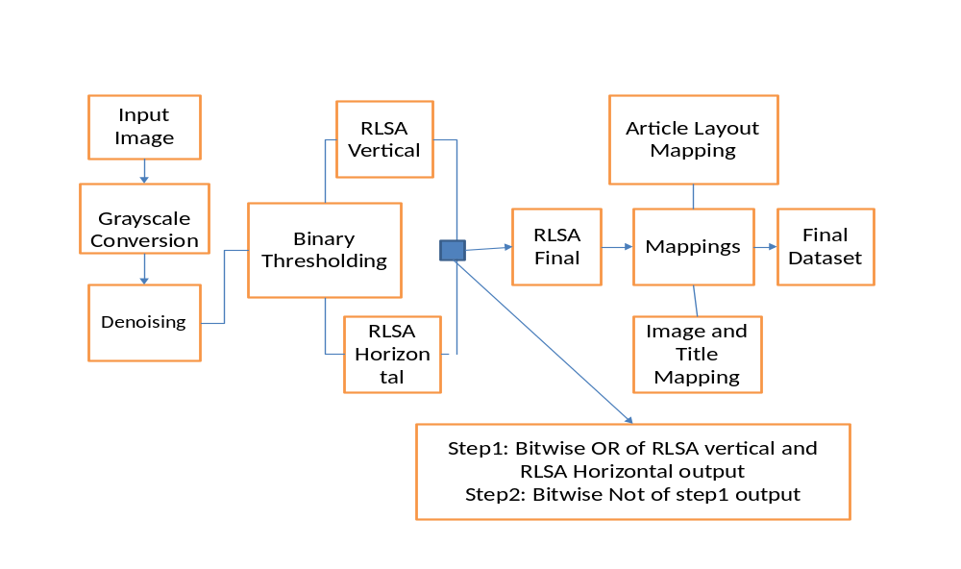
Fig. 1. Block diagram of the proposed methodology

As an initial step we read the input images in the format of Numpy array where RGB values for images are initialized.
A. Denoising
Denoising a method used to remove noise from the input image (fig.4b) is being considered. The fastNIMeansDenoising method is considered for smoothing. It looks for a particular change in the image.
B. Binary Thresholding
Thresholding of an image is said to be segmentation of image pixels into two different regions, one as foreground and other as background. These regions are segmented based on the threshold value set to the intensity of the pixels. Above the threshold is said to foreground and rest is said to be background which helps further methods to identify the region of interests to be analysed/processed. Thresholding can be easily applied only if the image is a grayscale. In our process most of the newspapers have white background and hence the threshold value will be selected close to the maximum pixel intensity as 255 for any 8-bit image.
C. Morphological Dilation
Generally, morphological operations are the operations carried out in the pixel intensities which changes the structure of the areas of interest within an image by altering the boundary pixels. After thresholding certain regions within the image will not be clear as no of pixels will be found missed. Those boundaries of regions and missing pixels can be expanded or distorted by applying a structural element of a particular square matrix which is also a binary image said to be kernels.(fig 2)

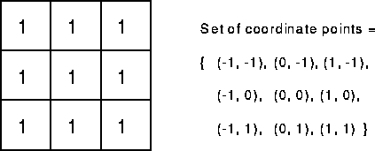

Fig. 2. A 3x3 kernel (structural element) used in dilation
For dilation this structural element is superimposed in the original image and adds the pixels to both the inner and outer boundaries of regions. Hence certain pixel regions found around the texts in the newspapers are expanded such that whole paragraphs can be segmented as blocks.
Second part of our work focuses on Block findings. The most important and required step in document understanding/classification. Methods used for finding each block found in the whole image are a) OCR and b) RLSA- run length smoothing algorithm.

A. OCR

For performing OCR (converts image to string, image to image) we use a commonly available engine pyTesseractocr engine a framework. It is majorly useful in text analysis alone but in our case for layout extraction it is noticed that it will identify text and make bounding boxes without using any contours method, thresholding method, the overall detected bounding boxes can be merged to say it as particular paragraphs for region detection. But here image is also considered as a text an error that is observed and failed to detect properly (fig. 3(a,b) ).

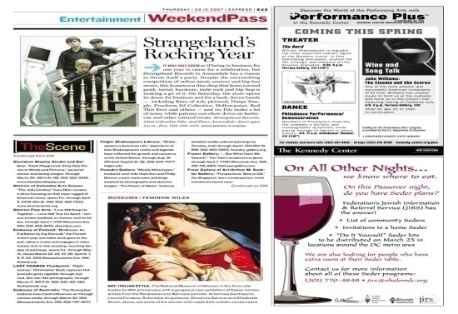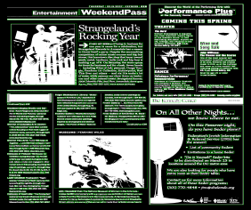
(a) (b)
Fig. 3. Results of applying OCR method (a) original image (b) OCR_result

B. Run Length Smoothing Algorithm

The run length smoothing algorithm is a procedure to identify the regions/blocks within an image consisting of texts, graphics, etc. These blocks can be segmented as words, paragraphs, titles, images, etc by using a sequence-based transformation along the n number of row and column pixels. This algorithm is applied in an image with a threshold value representing no of pixels in a sequence considered within the horizontal and vertical pixel arrangements. Input sequence is row-wise pixels found in the image and no of background pixel values (0’s) along the sequence are calculated. Only if then of 0’s in the sequence consecutively is less than the threshold value, then those pixels are altered to foreground pixel values of (1). When condition fails, the pixels remain the same.
Both horizontally and vertically (fig. 4(e,f)) the sequences are considered and applied with the algorithm to obtain as new binary images. From these two images, a logical OR operation is carried out followed by a logical NOT to eliminate the white spaces (fig. 4g ) and retain them as blocks (fig. 4h )
The major and important contribution of the RLSA algorithm chosen helps us to identify blocks in a very better way when compared to normal dilation and thresholding methods.

IV. EXPERIMENTAL RESULTS & DISCUSSIONS
The proposed method for region findings has been implemented in OpenCV language on a laptop Core(TM) i3-5005U CPU @2.00GHz with RAM 4.00GB & windows OS. Experimented on a dataset consisting of digital newspaper images of recent years with different layouts and found that the proposed algorithm segments various blocks including texts, images and graphics in the newspaper and extract them as separate elements as shown in fig. 4. Effectively these blocks will be used as features and evaluation measure for article segmentation algorithm.

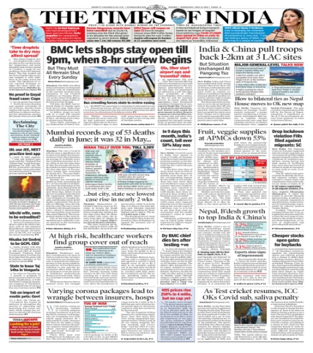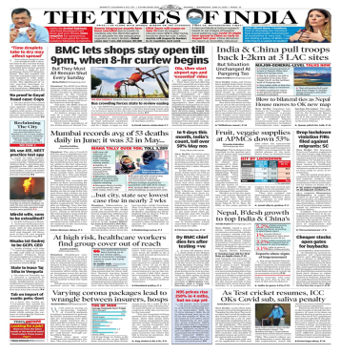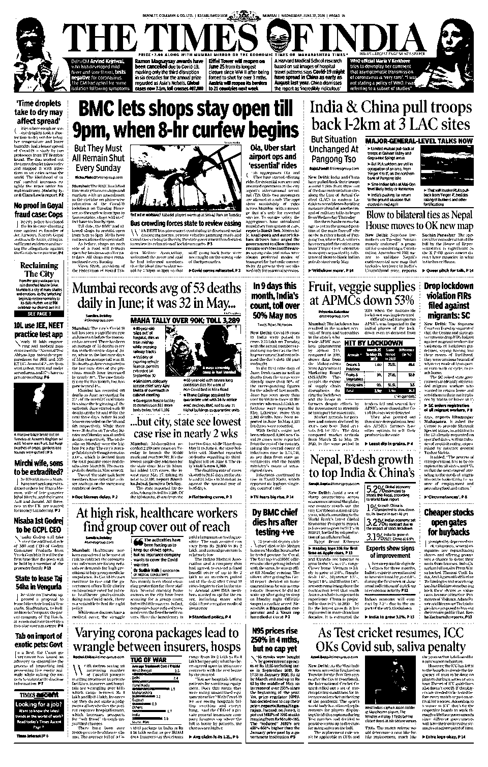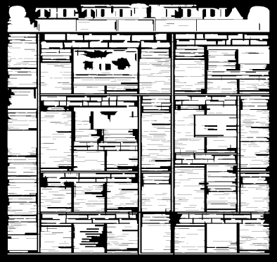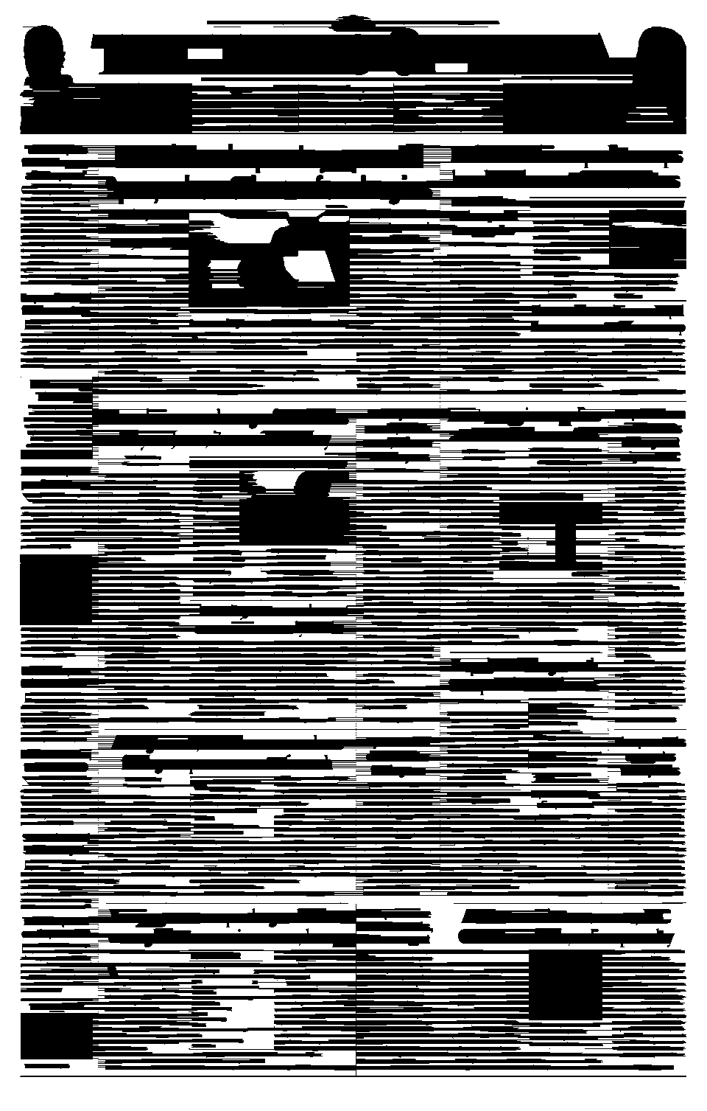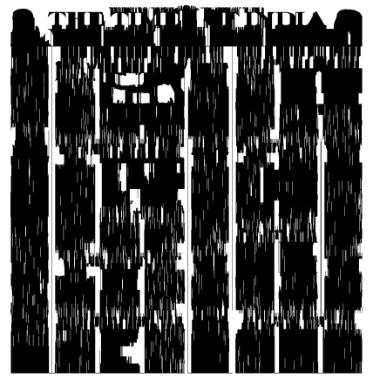
- (b) (c) (d) (e) (f)
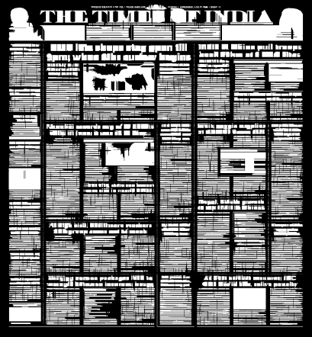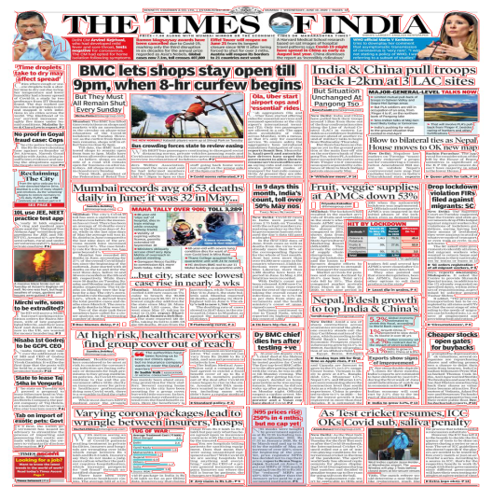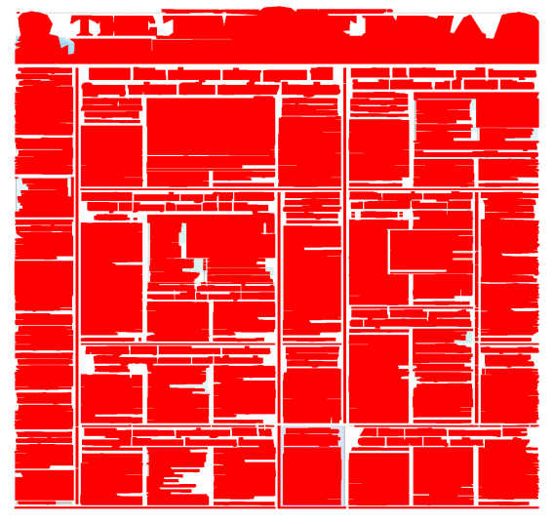
(g) (h) (i)
Fig. 4. Results of the proposed methodology (a) original image (b) Denoised image (c) Threshold image (d) Dilated
image (e) RLSA_h (f) RLSA_v (g) RLSA_f (h) Final result (i) Final result1

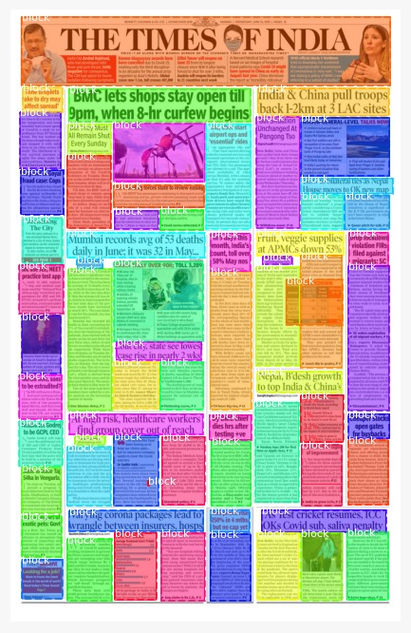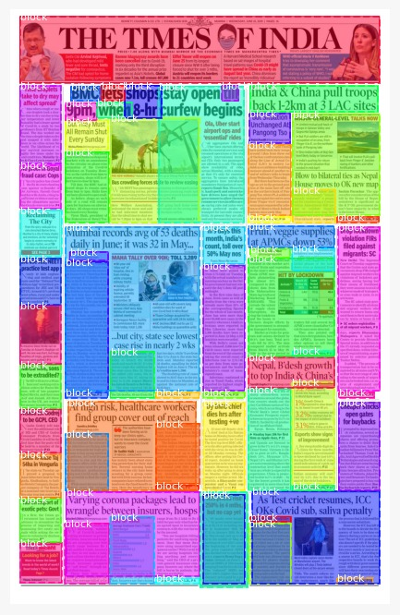
Fig. 5. Results of the proposed algorithm a)Grount truth b) Algorithm found

Above fig 5. Shows the results obtained by run length smoothing algorithm and Generated Ground Truth. By comparing both the results (fig. 5a & 5b) it is found that our proposed algorithm is unable to detect the regions where an image is shared by multiple blocks and needs to be improvised.

V. CONCLUSION
Block findings and analysis forms a major and first step towards building an efficient and complete model for document classification and analysis systems. Block findings is attained using certain methods such as thresholding, morphological dilations, OCR, RLSA, etc. Each block within an article contains main attributes such as title, contents, and images and these can be segmented using the identified blocks as one of the features to the machine learning model. It is found that OCR fails to detect the regions correctly and can be used for sentimental analysis, where as using RLSA we found outer region and individual regions as block findings Experimental results shows that compared to normal methods RLSA help us to identify blocks in a very better way with positive results. Future scope of the block segmentation is a)To label those blocks within each articles to study the layouts of the newspaper b) Detect the regions where an image is shared by multiple blocks.

Block Findings for Newspaper Images
Shilpa¹, Dr. Shridevi Soma²

1Department of Computer Science and Engineering, SUK Klb, Karnataka, India
2Department of Computer Science and Engineering, PDACE Klb, Karnataka,India

s123shilpa@gmail.com1, shridevisoma@gmail.com2

Abstract

Region findings and analysis plays an important role in document understanding. Due to complex layouts, document understanding is now a very challenging task for researchers. This paper proposes a simple method for block findings. The task of block findings is divided into two stages pre-processing and segmentation. Pre-processing techniques try to remove the unwanted distortions making document suitable for region findings in an efficient way, and segmentation in which we identify all blocks found in the document image finally carried out the experiments on our own dataset generated and found promising results.
Keywords – Region findings, Segmentation, complex layouts, unwanted distortions
I. INTRODUCTION
Document Digitisation is the process of taking a physical document or document representation and transferring it into a faithful digital representation. The ideal goal is to preserve all the information contained within the physical document as physical documents deteriorate overtime. It also achieves the goal of improved access, as digital documents can be quickly retrieved from archives and returned to a user, without them having to be in the same physical location as the document. Digitisation is necessary to allow sophisticated computer processing of documents.
Document layout analysis plays a vital role in processing the digitized documents in an efficient way and acts as a pre-processing step. The task of document layout analysis involves identifying and categorizing regions of interest on a given document image. Due to the complex layouts found in document image document understanding and analysis becomes difficult and in past many works has been initiated on this but till today there is no unique solution due to complexity of document as a result it remains as a challenging task and need to be addressed. In this paper we present methods to find the blocks present in the overall document and is carried out in two stages pre-processing and segmentation.
Rest of the paper is organized as fallows In Section II we present related work carried out, In Section III we present the details of the proposed methodology, In Section IV we present results, and finally the conclusions are presented in Section V.

II. RELATED WORK

There has been a wide range of literature available on topic document understanding and analysis. Tuan Anh Tran et al. (2018) [1] proposed an efficient hybrid method for page segmentation. The method includes two parts classification and segmentation. Connected component analysis and white space analysis are used for classifying text and non-text regions. Text regions during segmentation are retrieved by white space analysis and mathematical morphology. Non-text regions like graphs, tables, charts and many more are retrieved by ML process. Empirical computations on UWIII dataset found to be promising and faster. Processing time reduced by 1/3 when compared to multilevel algorithms.
Nasid Habib Barna et al. (2018) [2] presents(developed) a language independent segmentation system based on morphological operations which takes the input as heterogeneous document and produces output as homogenous components. The system segments homogenous components as title, image, and tables. Authors in order to improve the segmentation performance of the system have proposed two more methods RIFR and TETC and have achieved an overall accuracy of 93% but still failed in segmenting images and tables properly hence need to be addressed.
Nikos Vasilopoulos et al. (2017) [3] also proposed a hybrid method for layout analysis. The proposed method includes two methods contour classification and morphological operations. Experimental results on dataset consisting of coloured newspapers and journals gained accuracy more than 95% and execution time consumed was less than 0.5 second per page an added advantage over the other observed techniques.
Another hybrid method for layout findings has been proposed by Sebastian W. Alarcon Arenas et al. (2018) [4] which are also based on morphological operators and connected components. Findings include titles, text and non-text regions respectively. Author compared the overall results obtained with methods by Naik-Sofup and vasilopoulous-CCMO and found that a precision rate of 89.22%, recall-87.40%,F1 measure-87.46% was attained and outperformed with the others and as a pitfall it was also noted that the proposed method consumes more execution time i.e 132.03 seconds to execute.
A key contribution by Anukriti Bansal et al. (20) [5] in automatically learning the rules to identify the logical units of a given document image outperforms the available systems that rely on learning the rules to detect logical units. The proposed model fixed point model captures the conceptual information to predict the label of each block present in the news articles and therefore the model attained promising results.
Annus Zulﬁqar et al. (2019) [6] proposed a deep learning technique for logical layout analysis. The proposed method uses two layered RNN where text is passed as an input to the model where it tries to find and label zones. Empirical computations shows that the model achieves accuracy of 95.38% with random split and 96.21% for unseen layout from this the model works well for even the unseen layouts when compared to random split. Further the model can be trained to predict the corners of text blocks and with larger dataset size.
Dario Augusto Borges Oliveira et al. (2017) [7] proposed reduction in dimensionality (from 2D to 1D) based classification approach. The proposed architecture takes as an input two 1D arrays of horizontal and vertical projections of image tile and classifies them into text, images, tables then final class labelling assignment done. Empirical results shows that the proposed architecture outperforms state-of-art techniques by low data usage 50 times less and increasing the processing time by 7.8 times faster. Further the architecture can be improved by dealing with historical data and by increasing labels.
As a replacement to conventional CNN Sai Chandra Kosaraju et al. (2019) [8] introduces a new model “texture-based CNN” for layout findings and analysis. The model uses dilated CN layers which takes a tile image and generates a class label thereby outperforming the available conventional CNN techniques in classifying documents.
Mohammad Mohsin Reza et al. (2018) [9] presents a variant of any OCR system for invoices document layout analysis. The proposed method integrates technique of horizontal and vertical line removal methods to the original any OCR system in order to overcome drawback of over segmentation and helps in keeping the information in row by row thereby preserving the reading order. Experimental evaluations show that the proposed system gains a high accuracy of 83.34% when compared to earlier methods.
Looking back to the complexities involved in understanding the structure of a newspaper document Hui-Yin Wu et al.(2019) [13] proposed an approach towards understanding the structure and design of newspaper image. The approach takes as input the front page of newspaper and produces number of elements and design as output and is carried out in two stages a) Segmentation and b) Classification. Computer vision techniques are used for segmentation via curvilinear structure detection. CNN techniques are used for classification via fastai library. Finally both a quantitative analysis and a qualitative visualization is presented to users as result .
S. Pletschacher et al. (2010) [26] describes XML based PAGE framework in evaluating datasets in any infrastructure a research infrastructure, a production environment infrastructure. Due to its promising and efficient evaluation results the framework is now extensively used in many competitions series ICDAR, PRImA. Based on requirements the existing format can be extended to new gts subformats.
Focusing towards developing document layout evaluation system and page segmentation methods Thomas Strecker et al. (2009) [12] developed MyNews ground truth dataset generation system for newspaper layout analysis. The system takes as input news corpus and generates digital newspaper and XML file as output. The proposed system involves two stages a) layout generation b) Matching stage. The matching stage involves the fallowing steps a) Document is printed b) Scanning document c) Document image alignment that relies on RAST algorithm to find optimal parameters and finally d) Computing the coordinates of ground truth components in scanned image. Thus, generating a dataset with some layouts and as a future step the system can be extended to cover more general datasets.
From the above literature survey, it is found that the research work on document layout analysis has been initiated long ago due to the complexities involved in document but till today there is no unique solution to address the problem. It is noted that the concept of rule based method, non rule based method, hybrid methods have been used for document understanding and analysis. Recent survey says that works based on deep learning and neural network have been initiated and neural networks seems to be advantageous, more competitive and needs to address.
III. PROPOSED METHODOLOGY

The proposed methodology is implemented in two parts a) pre-processing and b) Blocks identifications. The aim of pre-processing is to improve the quality of the image so that we can analyse it in a better way. By pre-processing we can reduce undesired disturbances and enhance some features which are required for the application we are working for. Those features may vary from application to application.

A. Need for Preprocessing
Resizing of collected dataset images must be done before applying segmentation,all images should be made feature extractable with same kind of thresholding , Detecting major whitespaces in the newspaper to understand the unique layouts, Finding the grid structure (rows and columns) used within the article layouts, De-noising the images for better feature extraction especially in old newspapers, Segregating images along with respective articles within multiple grid sharing, Extracted elements and components are chosen according to their close influences the feature extraction.
Fig. 1. shows the block diagram of the proposed system and working is as fallows for block identification various methodologies are implemented where initially binary thresholding of images is carried out and then run-length smoothing algorithms are applied in order to extract those blocks as separate elements. As an initial step we read the input images in the format of Numpy array where RGB values for images are initialized.

A. Denoising

Denoising a method used to remove noise from the input image (fig.2c) is being considered. The fastNIMeansDenoising method is considered for smoothing. It looks for a particular change in the image.
B. Binary Thresholding

Thresholding of an image is said to be segmentation of image pixels into two different regions, one as foreground and other as background. These regions are segmented based on the threshold value set to the intensity of the pixels. Above the threshold is said to foreground and rest is said to be background which helps further methods to identify the region of interests to be analysed/processed. Thresholding can be easily applied only if the image is a grayscale. In our process most of the newspapers have white background and hence the threshold value will be selected close to the maximum pixel intensity as 255 for any 8-bit image.

C. Morphological Dilation

Generally, morphological operations are the operations carried out in the pixel intensities which changes the structure of the areas of interest within an image by altering the boundary pixels. After thresholding certain regions within the image will not be clear as no of pixels will be found missed. Those boundaries of regions and missing pixels can be expanded or distorted by applying a structural element of a particular square matrix which is also a binary image said to be kernels.(fig 1)

Fig. 1. A 3x3 kernel (structural element) used in dilation
For dilation this structural element is superimposed in the original image and adds the pixels to both the inner and outer boundaries of regions. Hence certain pixel regions found around the texts in the newspapers are expanded such that whole paragraphs can be segmented as blocks.
Second part of our work focuses on Block findings. The most important and required step in document understanding/classification. Methods used for finding each block found in the whole image are a) OCR and b) RLSA- run length smoothing algorithm.

A. OCR

For performing OCR (converts image to string, image to image) we use a commonly available engine pyTesseractocr engine a framework. It is majorly useful in text analysis alone but in our case for layout extraction it is noticed that it will identify text and make bounding boxes without using any contours method, thresholding method, the overall detected bounding boxes can be merged to say it as particular paragraphs for region detection. But here image is also considered as a text an error that is observed and failed to detect properly (fig. 2b).

B. Run Length Smoothing Algorithm

The run length smoothing algorithm is a procedure to identify the regions/blocks within an image consisting of texts, graphics, etc. These blocks can be segmented as words, paragraphs, titles, images, etc by using a sequence-based transformation along the n number of row and column pixels. This algorithm is applied in an image with a threshold value representing no of pixels in a sequence considered within the horizontal and vertical pixel arrangements. Input sequence is row-wise pixels found in the image and no of background pixel values (0’s) along the sequence are calculated. Only if then of 0’s in the sequence consecutively is less than the threshold value, then those pixels are altered to foreground pixel values of (1). When condition fails, the pixels remain the same.
Both horizontally and vertically (fig 2g & fig 2h), the sequences are considered and applied with the algorithm to obtain as new binary images. From these two images, a logical OR operation is carried out followed by a logical NOT to eliminate the white spaces (fig 2i) and retain them as blocks (fig 2j)
The major and important contribution of the RLSA algorithm chosen helps us to identify blocks in a very better way when compared to normal dilation and thresholding methods.
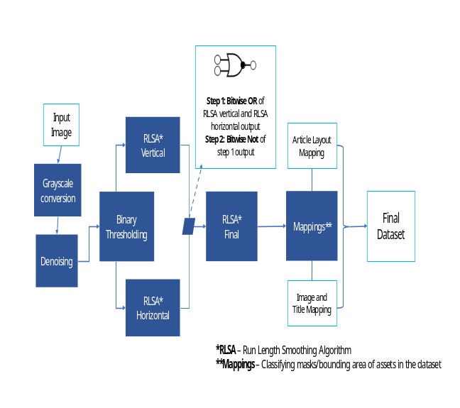Fig. 2. Block diagram of the proposed methodology
IV. RESULTS
- Original Image b) OCR-Result

- Original Image

d) Denoised image e) Threshold image
g) Dilated image h) RLSA_h
i) RLSA_v j)RLSA_f

j) Final Result k) Final_result1
Fig. 3. Results of proposed methodology

We have conducted the experiment on our dataset comprising of different and complex layouts. Fig 2b shows the result after applying pyTesseractocr method to original image Fig. 2a and is found that it misclassifies the data where even image is also considered as text. Fig. 2d shows result after applying denoising to original image Fig. 2c, Fig 2e shows the result of thresholding to original image Fig. 2c, Fig 2f. Shows the result of dilation to original image Fig. 2c, Fig. 2g shows the result of applying run length smoothing algorithm in horizontal direction to thresholded image Fig 2e, Fig. 2h shows the result of applying run length smoothing algorithm in vertical direction to thresholded image Fig. 2e, Fig. 2i shows the result of combining Fig. 2g and Fig. 2h by logical OR followed by logical NOT operator. Finally, the Fig. 2j shows the block identifications in the image and is represented clearly in Fig. 2k where we can see the detected regions on variations in white spaces. Experimental results found that the proposed method performs well with positive results.

V. CONCLUSION
Block findings and analysis forms a major and first step towards building an efficient and complete model for document classification and analysis systems. Block findings is attained using certain methods such as thresholding, morphological dilations, OCR, RLSA, etc. Each block within an article contains main attributes such as title, contents, and images and these can be segmented using the identified blocks as one of the features to the machine learning model. It is found that OCR fails to detect the regions correctly and can be used for sentimental analysis, where as using RLSA we found outer region and individual regions as block findings Experimental results shows that compared to normal methods RLSA help us to identify blocks in a very better way with positive results.

REFERENCES
[1] T. A. Tran, K. Nguyen-An, and N. Quang Vo, “Document layout analysis: A maximum homogeneous region approach,” 2018 1st Int. Conf. Multimed. Anal. Pattern Recognition, MAPR 2018 - Proc., vol. 2018-Janua, pp. 1–6, 2018, doi: 10.1109/MAPR.2018.8337515.
[2] N. H. Barna, T. I. Erana, S. Ahmed, and H. Heickal, “Segmentation of Heterogeneous Documents into Homogeneous Components using Morphological Operations,” Proc. - 17th IEEE/ACIS Int. Conf. Comput. Inf. Sci. ICIS 2018, pp. 513–518, 2018, doi: 10.1109/ICIS.2018.8466395.
[3] N. Vasilopoulos and E. Kavallieratou, “Complex layout analysis based on contour classification and morphological operations,” Eng. Appl. Artif. Intell., vol. 65, no. June, pp. 220–229, 2017, doi: 10.1016/j.engappai.2017.08.002.
[4] S. W. Alarcon Arenas, Y. Yari, and G. Meza-Lovon, “A Document layout analysis method based on morphological operators and connected components,” Proc. - 2018 44th Lat. Am. Comput. Conf. CLEI 2018, pp. 622–631, 2018, doi: 10.1109/CLEI.2018.00080.
[5] A. Bansal, S. Chaudhury, S. D. Roy, and J. B. Srivastava, “Newspaper article extraction using hierarchical fixed point model,” Proc. - 11th IAPR Int. Work. Doc. Anal. Syst. DAS 2014, pp. 257–261, 2014, doi: 10.1109/DAS.2014.42.
[6] A. Zulfiqar, A. Ul-Hasan, and F. Shafait, “Logical Layout Analysis using Deep Learning,” 2019 Digit. Image Comput. Tech. Appl. DICTA 2019, 2019, doi: 10.1109/DICTA47822.2019.8946046.
[7] B. Oliveira, “Fast CNN-based document layout analysis,” pp. 1173–1180.
[8] S. C. Kosaraju et al., “DoT-Net: Document layout classification using texture-based CNN,” Proc. Int. Conf. Doc. Anal. Recognition, ICDAR, pp. 1029–1034, 2019, doi: 10.1109/ICDAR.2019.00168.
[9] M. M. Reza, “A High-Performance Document Image Layout Analysis for Invoices,” no. April, 2018.
[10] B. Gatos, S. L. Mantzaris, K. V. Chandrinos, A. Tsigris, and S. J. Perantonis, “Integrated algorithms for newspaper page decomposition and article tracking,” Proc. Int. Conf. Doc. Anal. Recognition, ICDAR, pp. 563–566, 1999, doi: 10.1109/ICDAR.1999.791849.
[11] D. Wang and S. N. Srihari, “Classification of newspaper image blocks using texture analysis,” Comput. Vision, Graph. Image Process., vol. 47, no. 3, pp. 327–352, 1989, doi: 10.1016/0734-189X(89)90116-3.
[12] T. Strecker, J. Van Beusekom, S. Albayrak, and T. M. Breuel, “Automated ground truth data generation for newspaper document images,” Proc. Int. Conf. Doc. Anal. Recognition, ICDAR, no. April 2015, pp. 1275–1279, 2009, doi: 10.1109/ICDAR.2009.214.
[13] H.-Y. Wu and P. Kornprobst, “Multilayered Analysis of Newspaper Structure and Design,” no. RR-9281, 2019, [Online]. Available: https://hal.inria.fr/hal-02177784.
[14] B. Meier, T. Stadelmann, J. Stampfli, M. Arnold, and M. Cieliebak, “Fully Convolutional Neural Networks for Newspaper Article Segmentation,” Proc. Int. Conf. Doc. Anal. Recognition, ICDAR, vol. 1, pp. 414–419, 2017, doi: 10.1109/ICDAR.2017.75.
[15] C. L. Liu, G. A. Fink, V. Govindaraju, and L. Jin, “Special issue on deep learning for document analysis and recognition,” Int. J. Doc. Anal. Recognit., vol. 21, no. 3, pp. 159–160, 2018, doi: 10.1007/s10032-018-0310-5.
[16] S. Ares Oliveira, B. Seguin, and F. Kaplan, “DhSegment: A generic deep-learning approach for document segmentation,” Proc. Int. Conf. Front. Handwrit. Recognition, ICFHR, vol. 2018-Augus, pp. 7–12, 2018, doi: 10.1109/ICFHR-2018.2018.00011.
[17] A. Almutairi and M. Almashan, “Instance segmentation of newspaper elements using mask R-CNN,” Proc. - 18th IEEE Int. Conf. Mach. Learn. Appl. ICMLA 2019, pp. 1371–1375, 2019, doi: 10.1109/ICMLA.2019.00223.
[18] D. Hebert, T. Palfray, S. Nicolas, P. Tranouez, and T. Paquet, “Automatic article extraction in old newspapers digitized collections,” ACM Int. Conf. Proceeding Ser., pp. 3–8, 2014, doi: 10.1145/2595188.2595195.
[19] C. Clausner, A. Antonacopoulos, and S. Pletschacher, “ICDAR2017 Competition on Recognition of Documents with Complex Layouts - RDCL2017,” Proc. Int. Conf. Doc. Anal. Recognition, ICDAR, vol. 1, pp. 1404–1410, 2017, doi: 10.1109/ICDAR.2017.229.
[20] A. M. Namboodiri and A. K. Jain, “Document Structure and Layout Analysis,” no. March 2007, pp. 29–48, 2007, doi: 10.1007/978-1-84628-726-8_2.
[21] https://www.primaresearch.org
[22] M. Li et al., “DocBank: A Benchmark Dataset for Document Layout Analysis,” pp. 949–960, 2021, doi: 10.18653/v1/2020.coling-main.82.
[23] S. Pletschacher and A. Antonacopoulos, “The PAGE (Page Analysis and Ground-truth Elements) format framework,” Proc. - Int. Conf. Pattern Recognit., pp. 257–260, 2010, doi: 10.1109/ICPR.2010.

